Program Code:

#include <stdio.h>
void main(){
int n,m,i,j,k,flag1=1,flag2=1,pno,l=0;
char ans='n';
printf("\n Enter total number of processes : ");
scanf("%d", &n);
printf("\n Enter total number of resources : ");
scanf("%d", &m);
int Alloc[n][m],Max[n][m],Need[n][m],Avail[m],Request[m],Finish[n],Work[m],count=0,flag,sequence[n];
for(i = 0; i < n; i++){
printf("\n Process %d\n", i);
for(j = 0; j < m; j++){
printf(" Allocation for resource %d : ", j+1 );
scanf("%d", &Alloc[i][j]);
printf(" Maximum for resource %d : ", j+1 );
scanf("%d", &Max[i][j]);
}
}
printf("\n Available Resources : \n");
for (j = 0; j < m; j++){
printf(" Resource %d : ", j+1);
scanf("%d", &Avail[j]);
}
for(i = 0; i < n; i++){
for (j = 0; j < m; j++){
Need[i][j] = Max[i][j] - Alloc[i][j];
}
}
printf("\n Whether want to raise a resource request(y/n) : ");
scanf("%c", &ans);
scanf("%c", &ans);
if(ans=='y'){
printf("\n Enter the process no. for resource request : ");
scanf("%d", &pno);
for(j = 0; j < m; j++){
printf(" Request for resource %d : ", j+1 );
scanf("%d", &Request[j]);
}
for(j = 0; j < m; j++){
if(Request[j]>Need[pno][j]){
flag1=0;
break;
}
if(Request[j]>Avail[j]){
flag2=0;
break;
}
}
if((flag1==1) && (flag2==1)){
for (j = 0; j < m; j++){
Avail[j] = Avail[j]-Request[j];
Alloc[pno][j] = Alloc[pno][j]+Request[j];
Need[pno][j] = Need[pno][j]-Request[j];
}
printf("\n Request Granted ");
}else{
printf("\n Request can't be Granted ");
}
}
printf("\n Allocation Matrix : \n");
for(i = 0; i < n; i++){
for (j = 0; j < m; j++){
printf(" %d ",Alloc[i][j]);
}
printf("\n");
}
printf("\n Maximum Matrix : \n");
for(i = 0; i < n; i++){
for (j = 0; j < m; j++){
printf(" %d ",Max[i][j]);
}
printf("\n");
}
printf("\n Available Matrix : \n");
for (j = 0; j < m; j++){
printf(" %d ",Avail[j]);
}
printf("\n\n Need Matrix : \n");
for(i = 0; i < n; i++){
for (j = 0; j < m; j++){
printf(" %d ",Need[i][j]);
}
printf("\n");
}
for(i=0;i<n;i++){
Finish[i]=0;
}
for(j=0;j<m;j++){
Work[j]=Avail[j];
}
for (k = 0; k < n; k++){
for (i = 0; i < n; i++){
if (Finish[i] == 0){
flag = 0;
for (j = 0; j < m; j++){
if (Need[i][j] > Work[j]){
flag = 1;
}
}
if (flag== 0 && Finish[i] == 0){
for (j = 0; j < m; j++){
Work[j] += Alloc[i][j];
}
Finish[i] = 1;
count++;
sequence[l]=i;
l++;
}
}
}
}
if(count==n){
printf(" Safe Sequence : ");
for(i=0;i<l;i++){
printf(" P%d ",sequence[i]);
}
}else{
printf(" Deadlock Occurs ");
}
}
Sample Output :

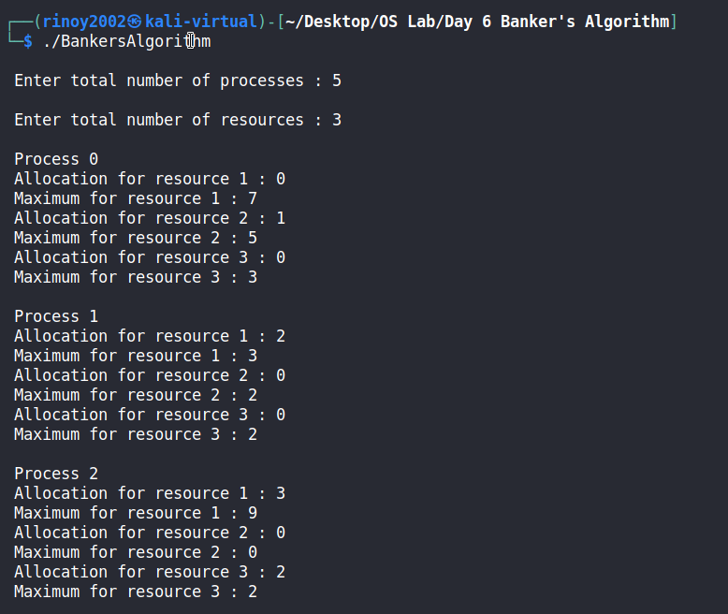
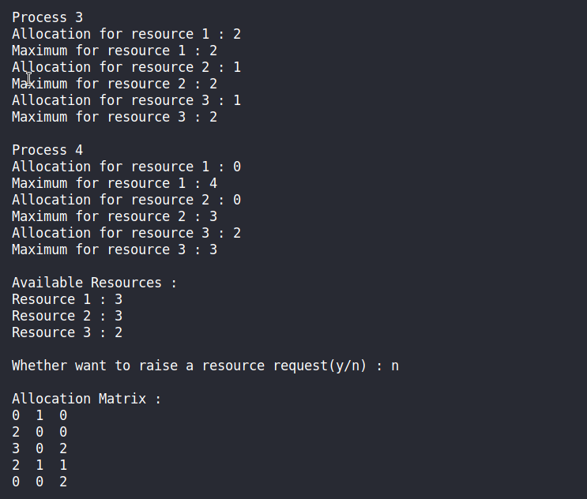

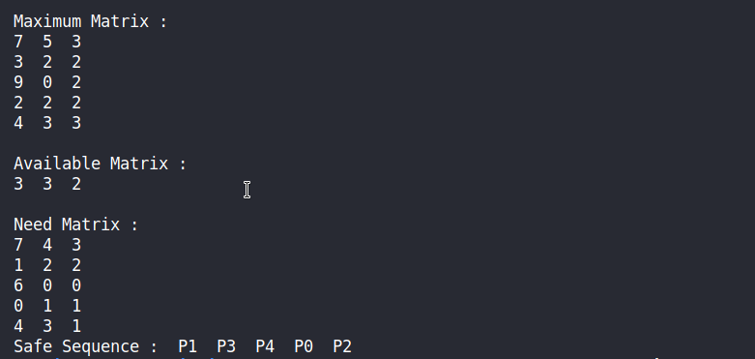

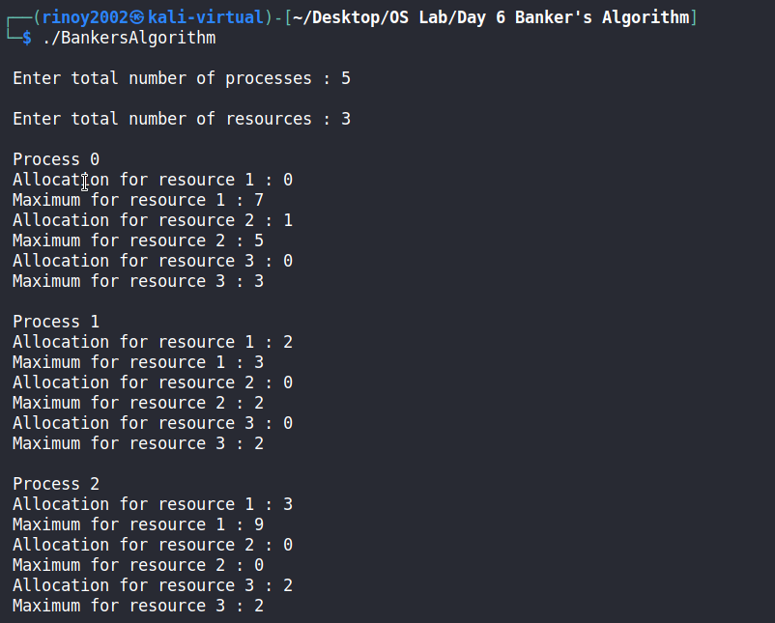
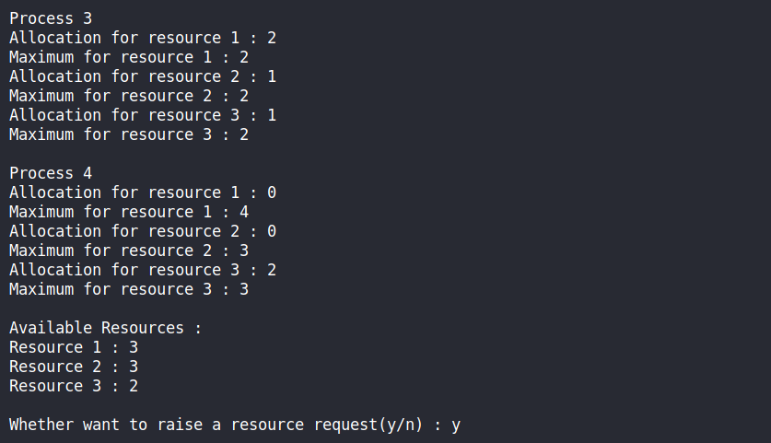

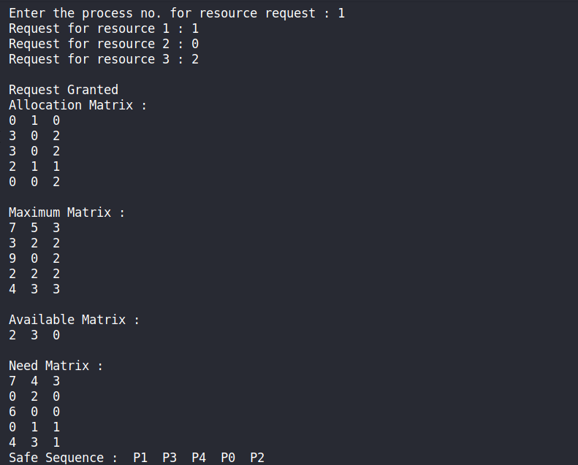

Program Code:

#!/bin/bash
test $1 = $2 && echo "both strings are same" || echo "both strings are different"

